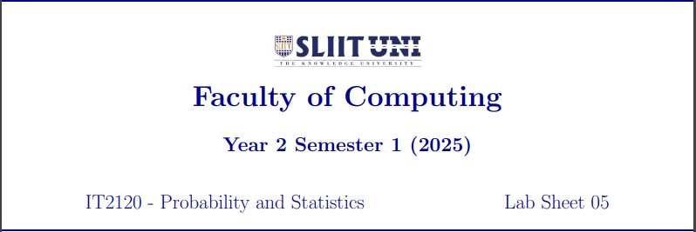

Question 01

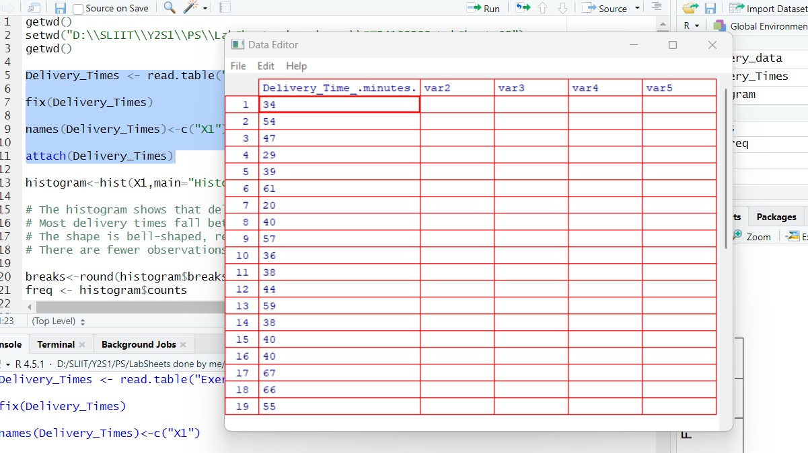

Question 02

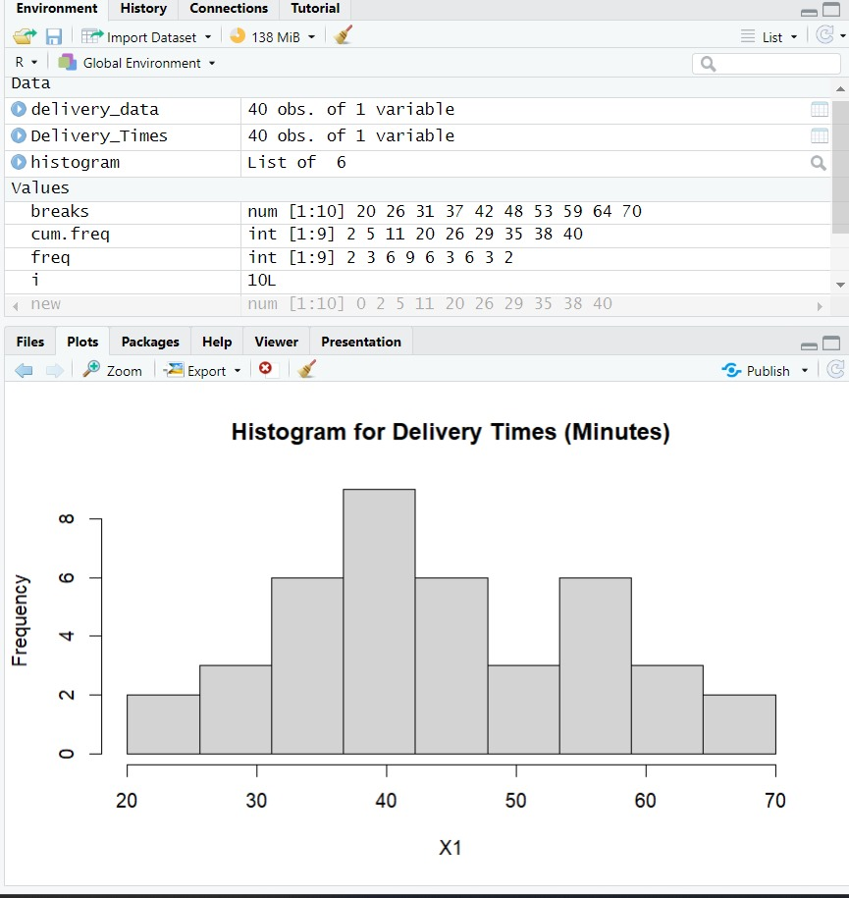

Question 03

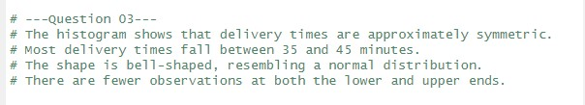

Question 04

